What

How

How do…?

What do…?

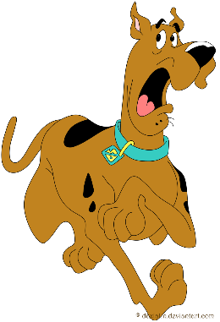

Why

Who

Why do…?

Who do…?

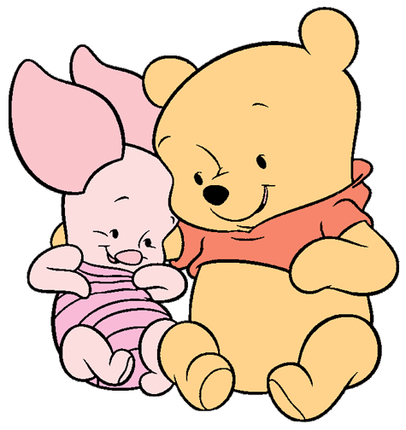



When

Where

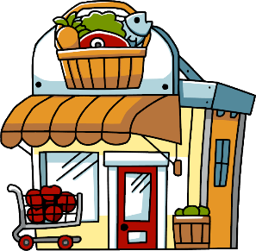

When do…?

Where do…?

Which do…?

Which

