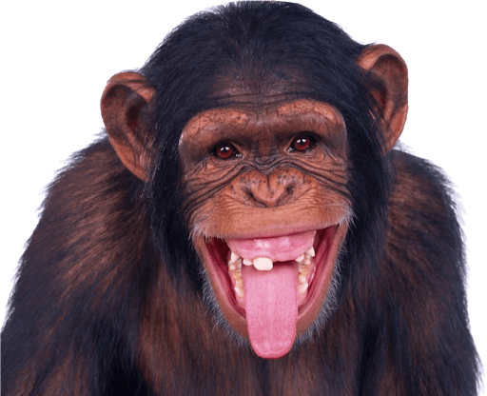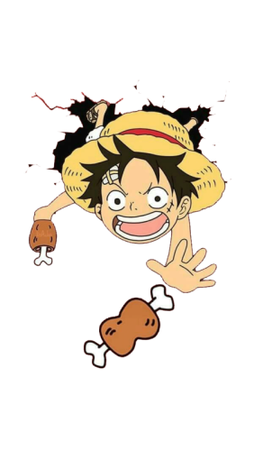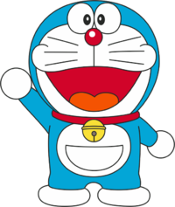

What do they like?

What does she like?

What does he like?